Terraform 01
Install Terraform on your PC
#Steps To Install Terraform on Windows 10 or 8 or 7
1) Download Terraform
https://developer.hashicorp.com/terraform/install#windows
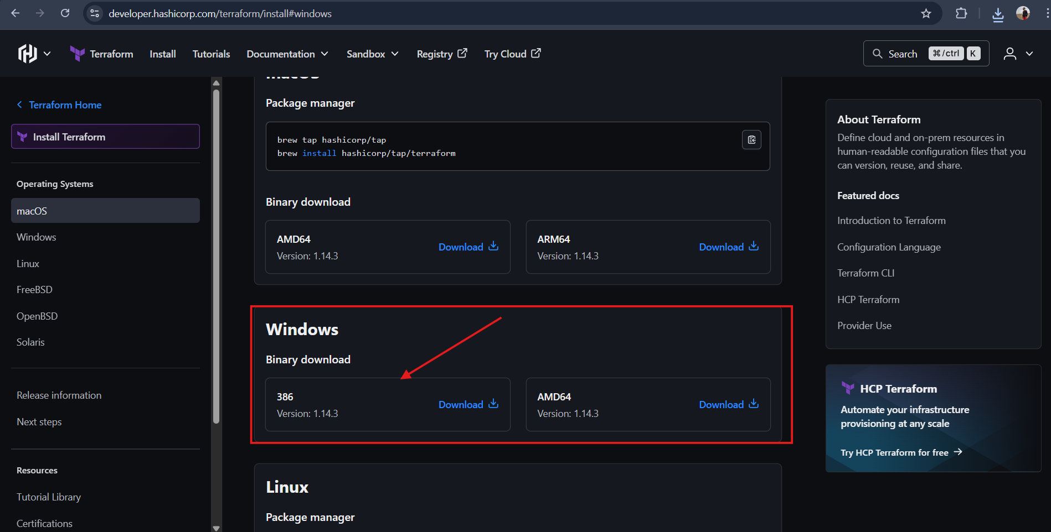
2) Unzip the terraform package
Extract the downloaded zip file, after extracting the zip file you can see terraform.exe file.
Extracted path can be Example "C:\Users\devops\Downloads\terraform_0.12.23_windows_amd64"
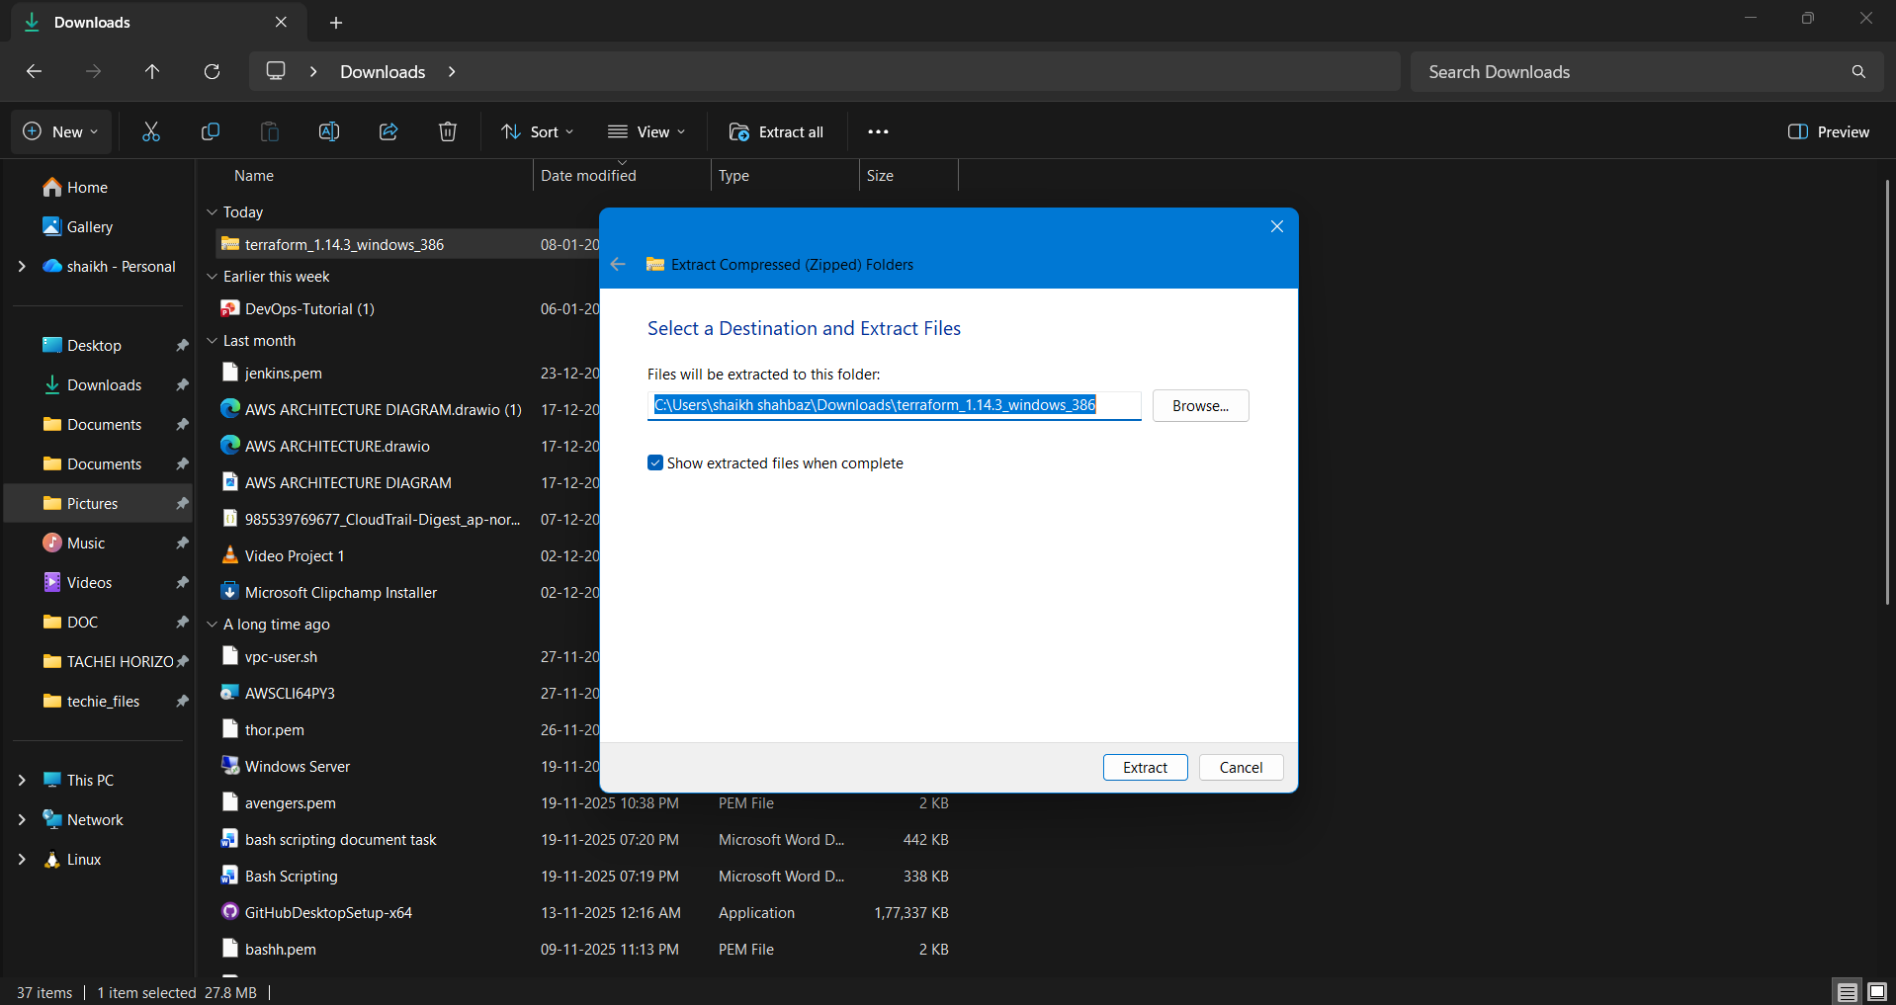
3) Configure environment variables for terraform
This PC(MyComputer)—>properties —>advanced system settings–>environment variables—>system variables—>path–edit–>new
paste the path "C:\Users\devops\Downloads\terraform_0.12.23_windows_amd64"
Click on Ok.
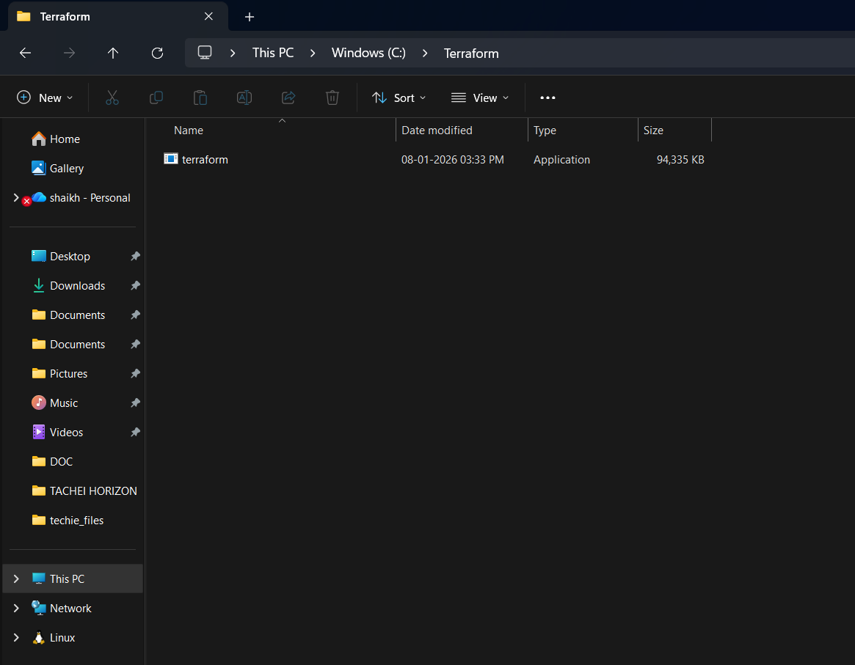
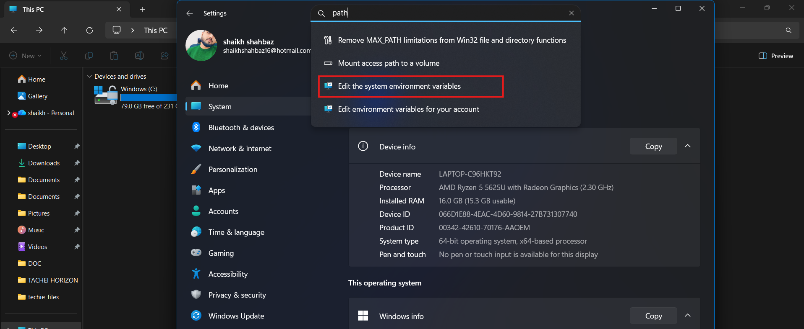
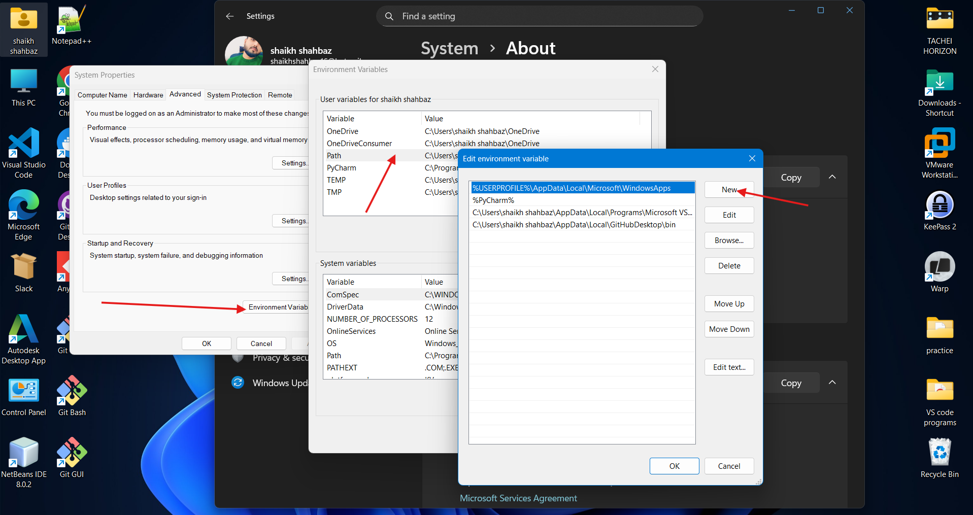

4) Verify terraform version
Open gitbash and enter
> terraform version
Terraform v0.12.23
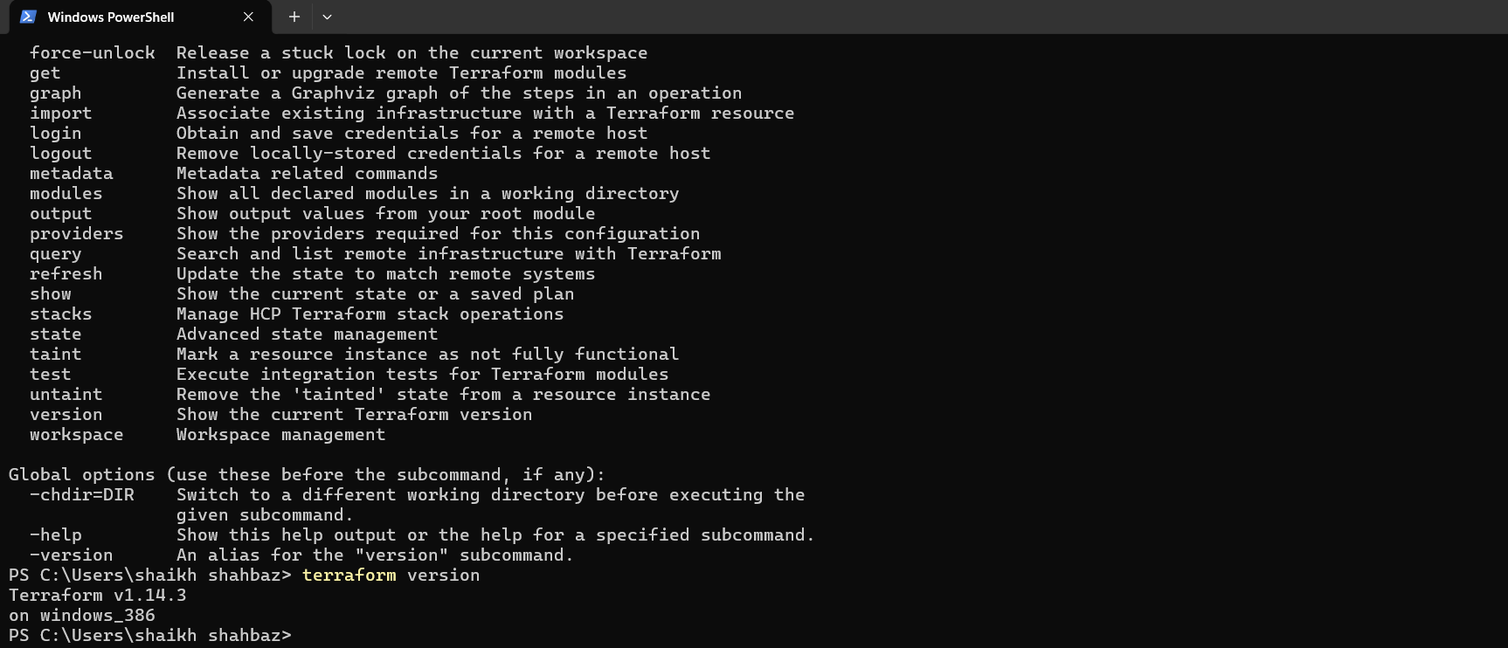
Execute all the templates shown in video.
Step 1: Create Your First Terraform Project
Make a new folder for your project (example: terra).
And open the folder it in the vs code
Inside the folder , create your first Terraform file:
In VS Code → File → New File → save as main.tf.
Write a smaple content in it

resource "local_file" "pet" {
filename = "/root/pets.txt"
content = "we love pets!"
}

- Note down below points,
terraform init
terraform init --> to initliaze the repository and download the dependencies

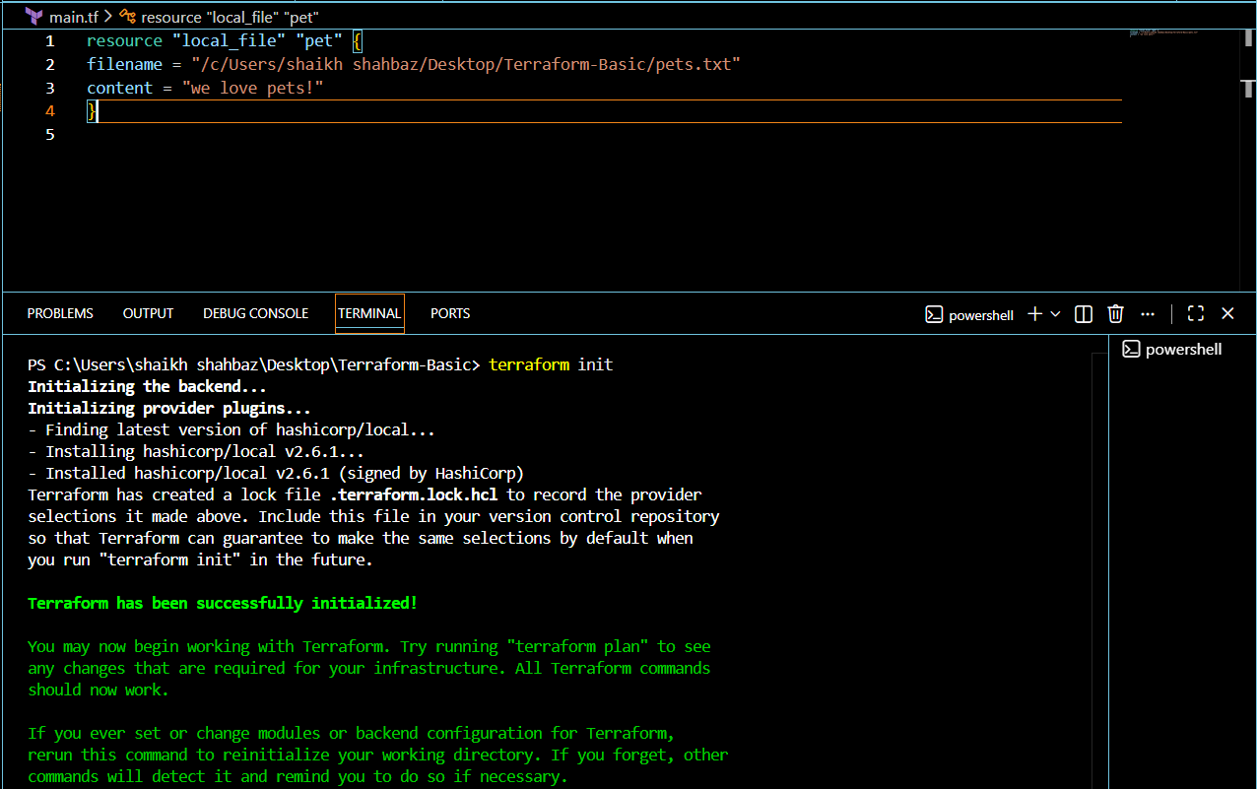
terraform plan
terraform plan --> dry run to check how it will be create the respource (It will not actually create them)
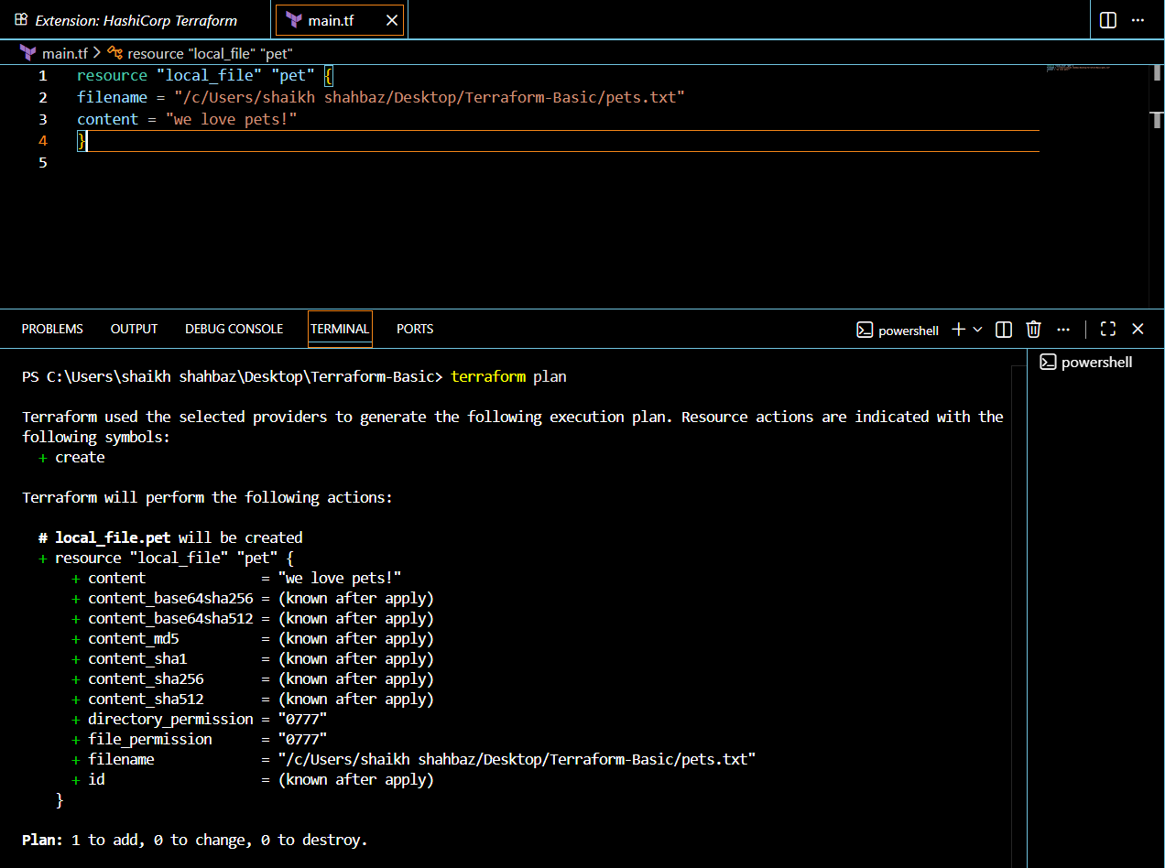
terraform apply
terraform apply --> to execute and create the infra based on the configuration
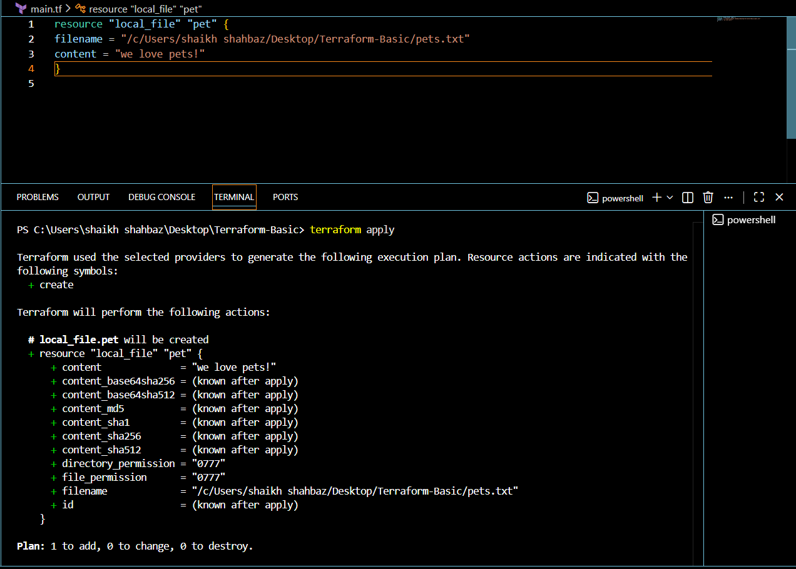
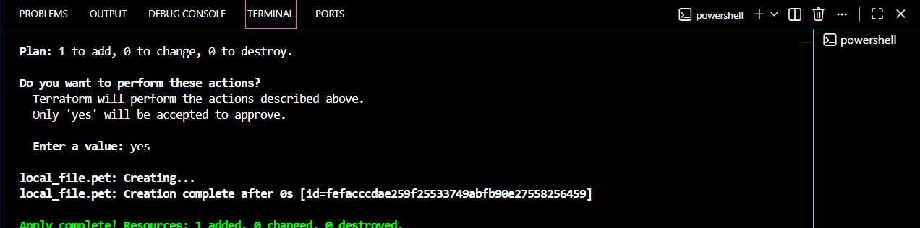
Terraform destroy
terraform destroy --> to remove/delete the existing infra.
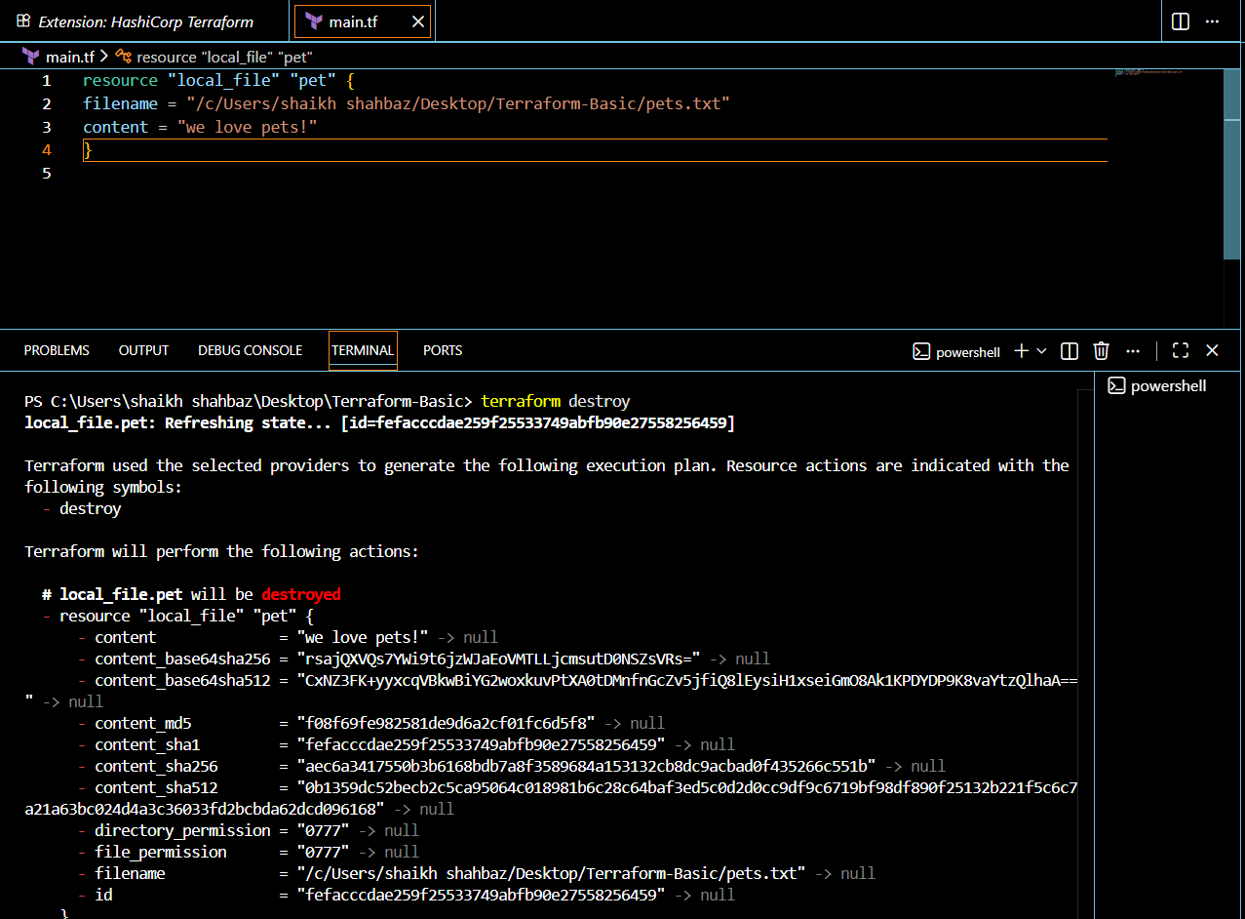
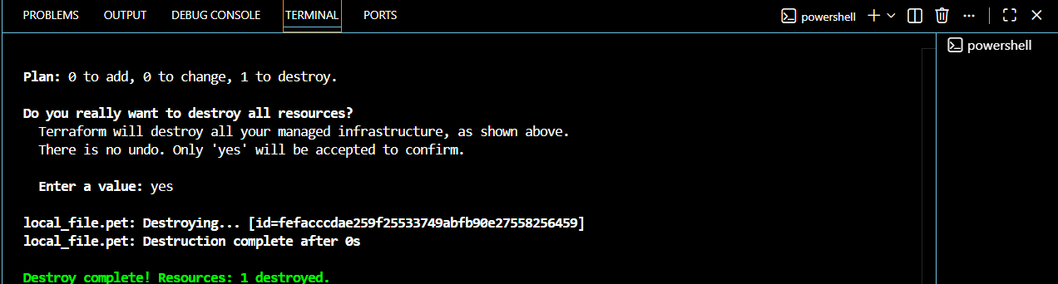
Terraform show
terraform show --> to show/get the details of the resources created
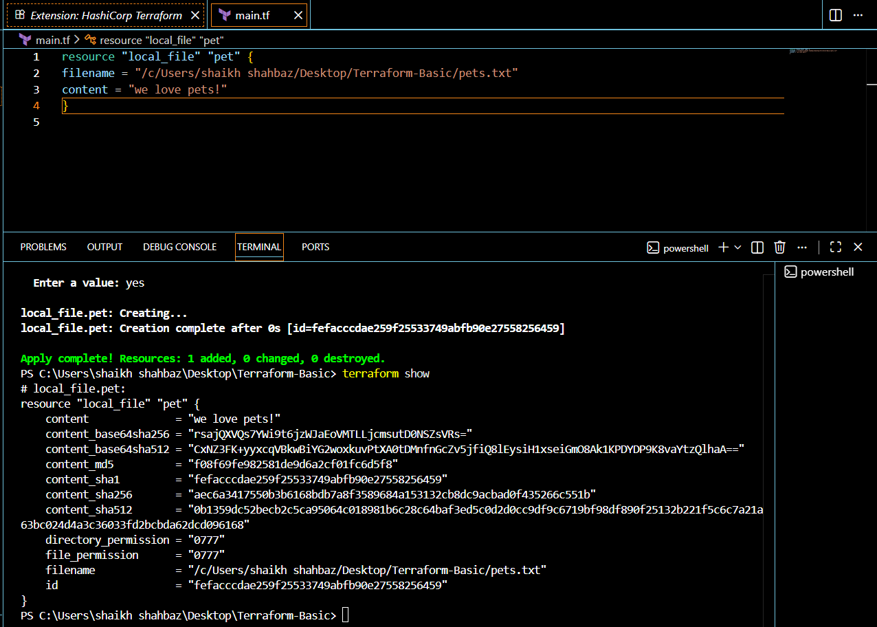

Note down below points,
Terraform Init
Command: terraform init
• Purpose:
o Initializes a Terraform working directory.
o Downloads required providers and modules.
o Creates a hidden .terraform folder to manage plugins.
• You must run this once per project (or after changing providers).
Terraform Plan
Command: terraform plan
Purpose:
• Shows the execution plan before making any changes.
• Compares your configuration (.tf files) with the real infrastructure.
• Helps verify what will be created, modified, or destroyed.
Safe to run multiple times (doesn’t change resources).
Terraform Apply
Command: terraform apply
Purpose:
• Executes the actions from the plan.
• Actually creates, updates, or deletes resources.
• Terraform will ask for confirmation (yes) before applying.
After running, infrastructure is live.
Terraform Provider
A plugin that lets Terraform interact with cloud platforms, SaaS, or APIs.
Example providers: aws, azurerm, google, kubernetes, docker.

- Integrate a sample Terraform template in Jenkins.
Objective:
To integrate a sample Terraform template with Jenkins so that
Terraform commands can be executed automaOcally using a
Jenkins pipeline.
Prerequisites:
1. Jenkins server up and running.
2. Terraform installed on Jenkins server (terraform -v should work).
3. Git is installed on Jenkins server
4. A Git repo containing Terraform code (for example: main.J). And jenkisfile
Install terraform plugin

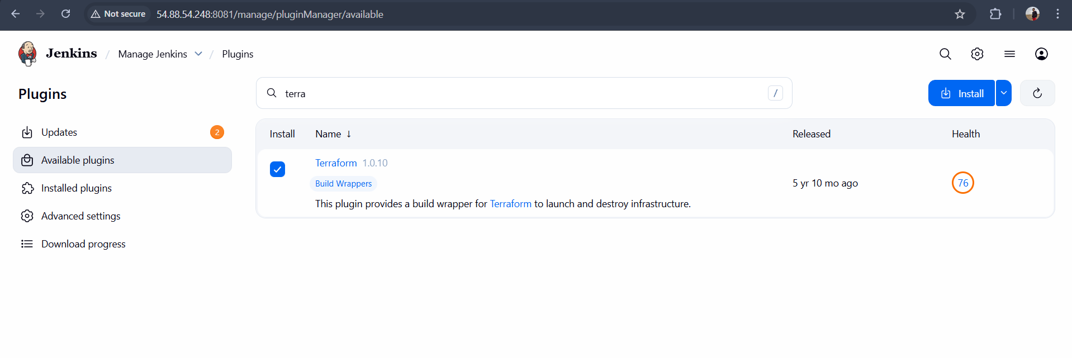

Step-1: In Jenkins server install terraform
wget https://releases.hashicorp.com/terraform/1.14.3/terraform_1.14.3_linux_amd64.zip
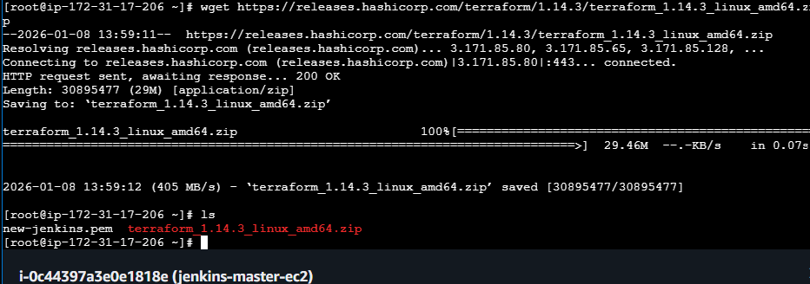

unzip terraform_1.14.3_linux_amd64.zip
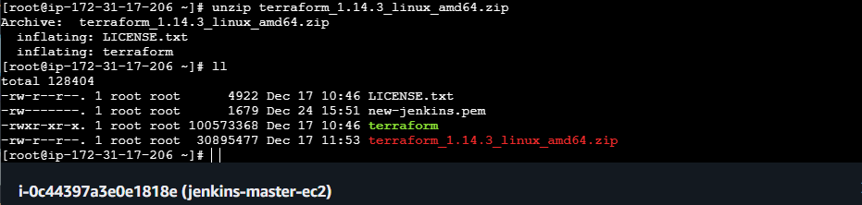
mv terraform /usr/local/bin/
terraform -v
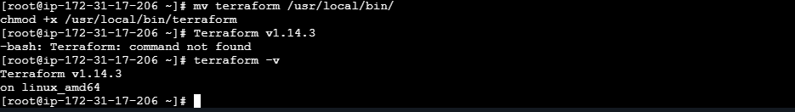

step 2:
In Jenkins tools added terraform
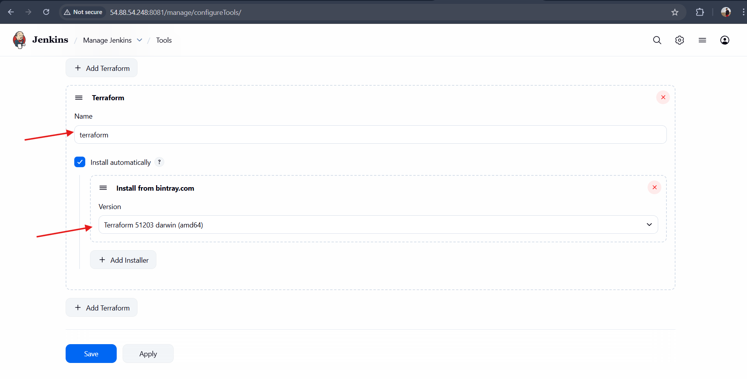
Step 3:
Create a New repo in git hub and 2 new files main.tf and Jenkinfile
in the git hub repo
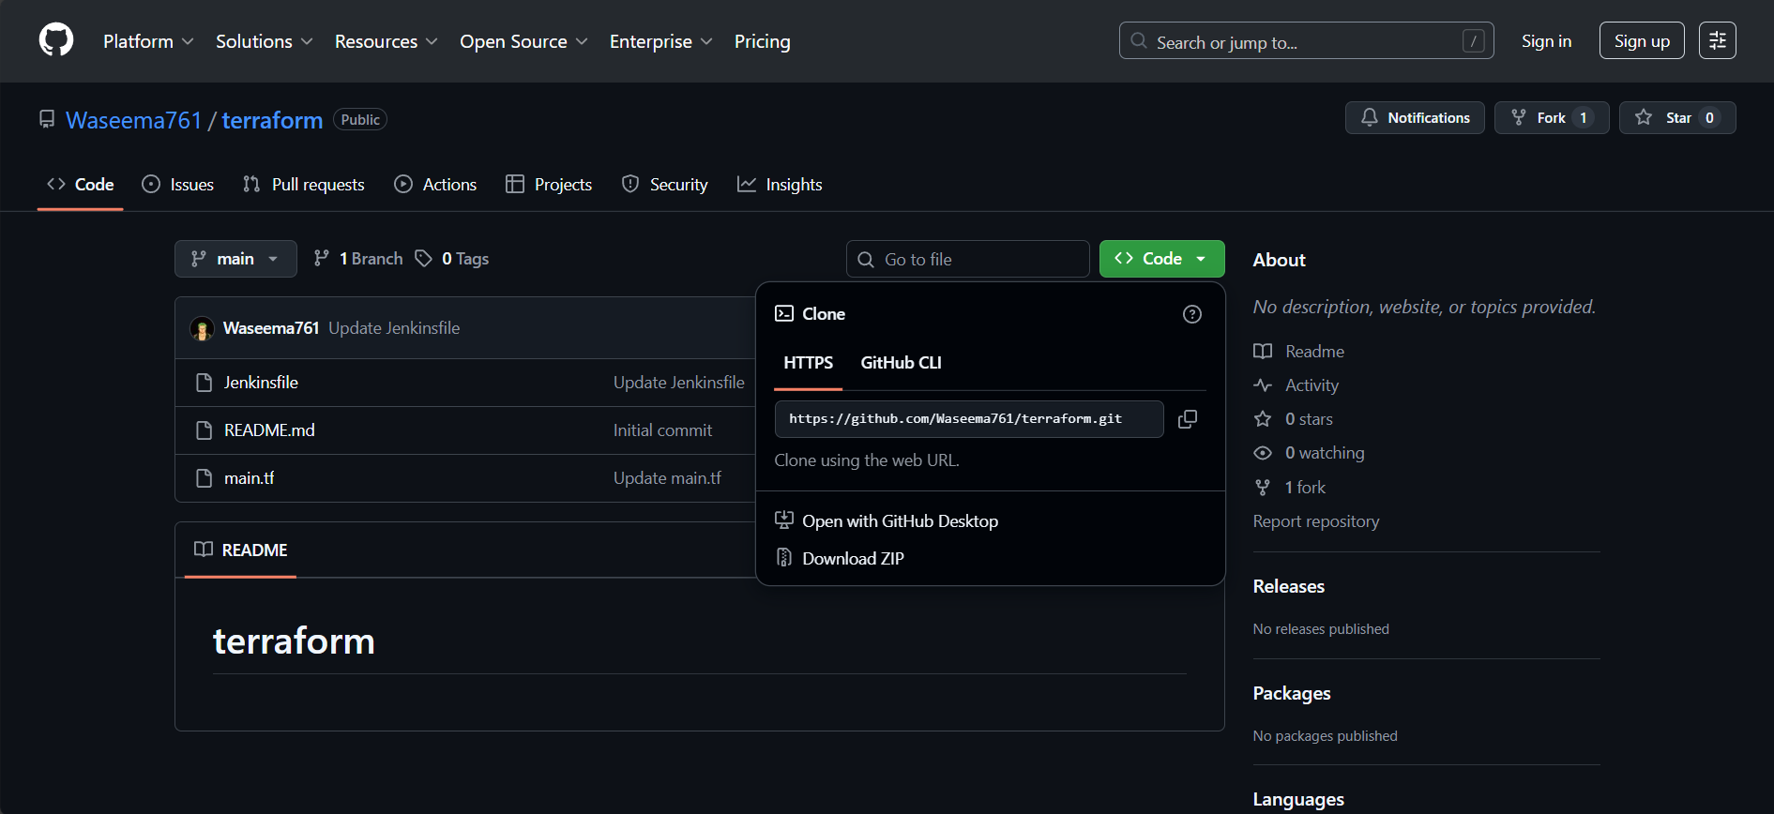

Step 4:
Create a new item terraform-job in Jenkins
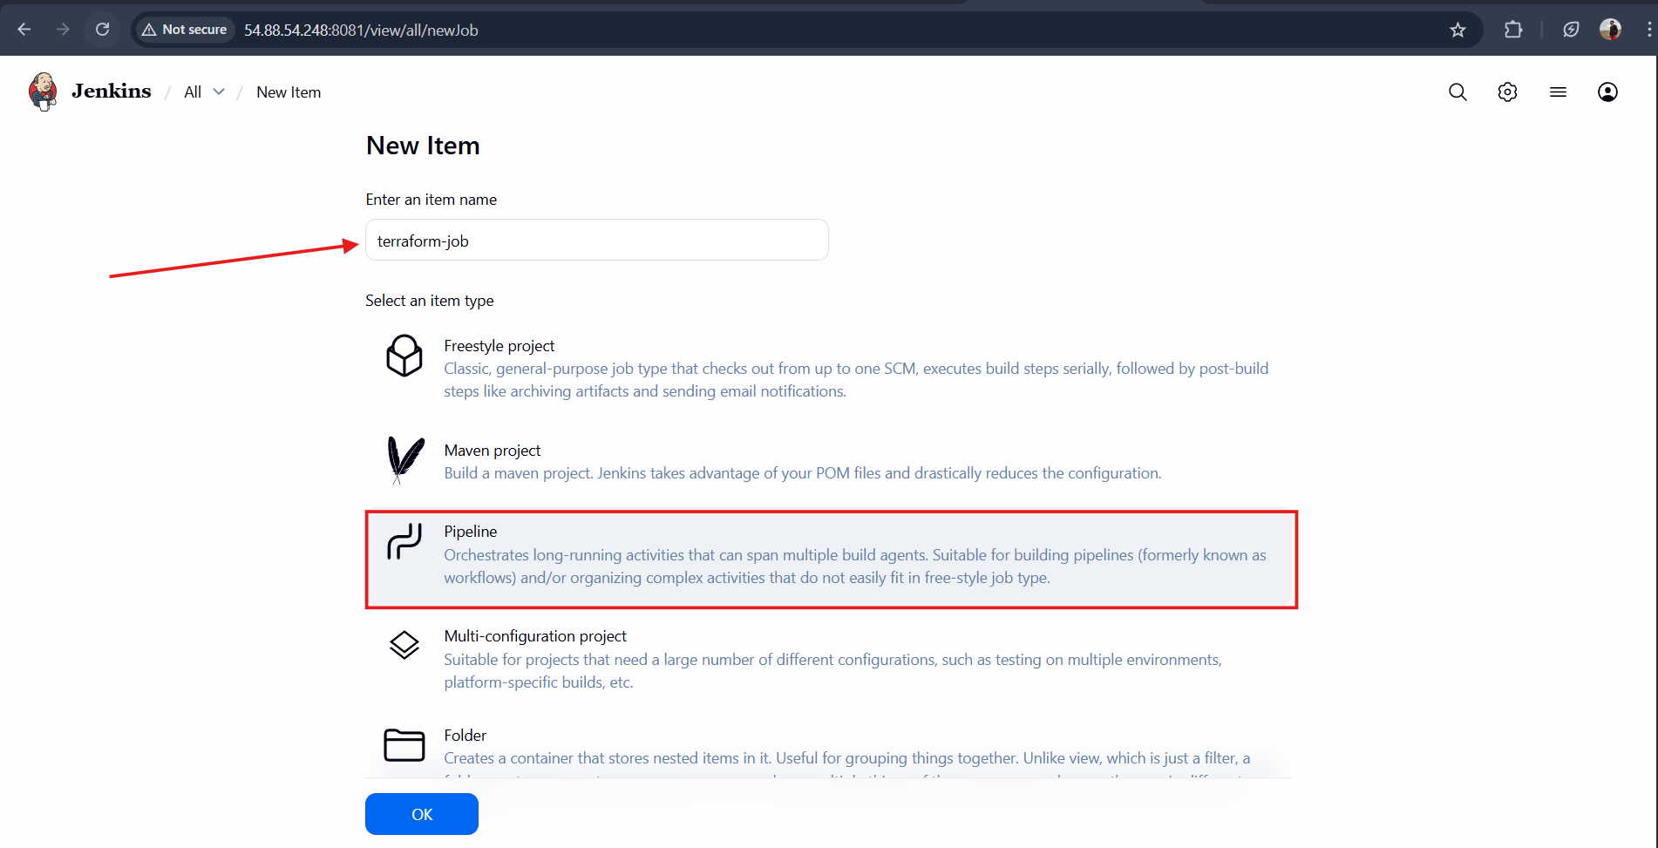
And select the pipeline and the git hub url and the branch in the configurations
—-> save the and build
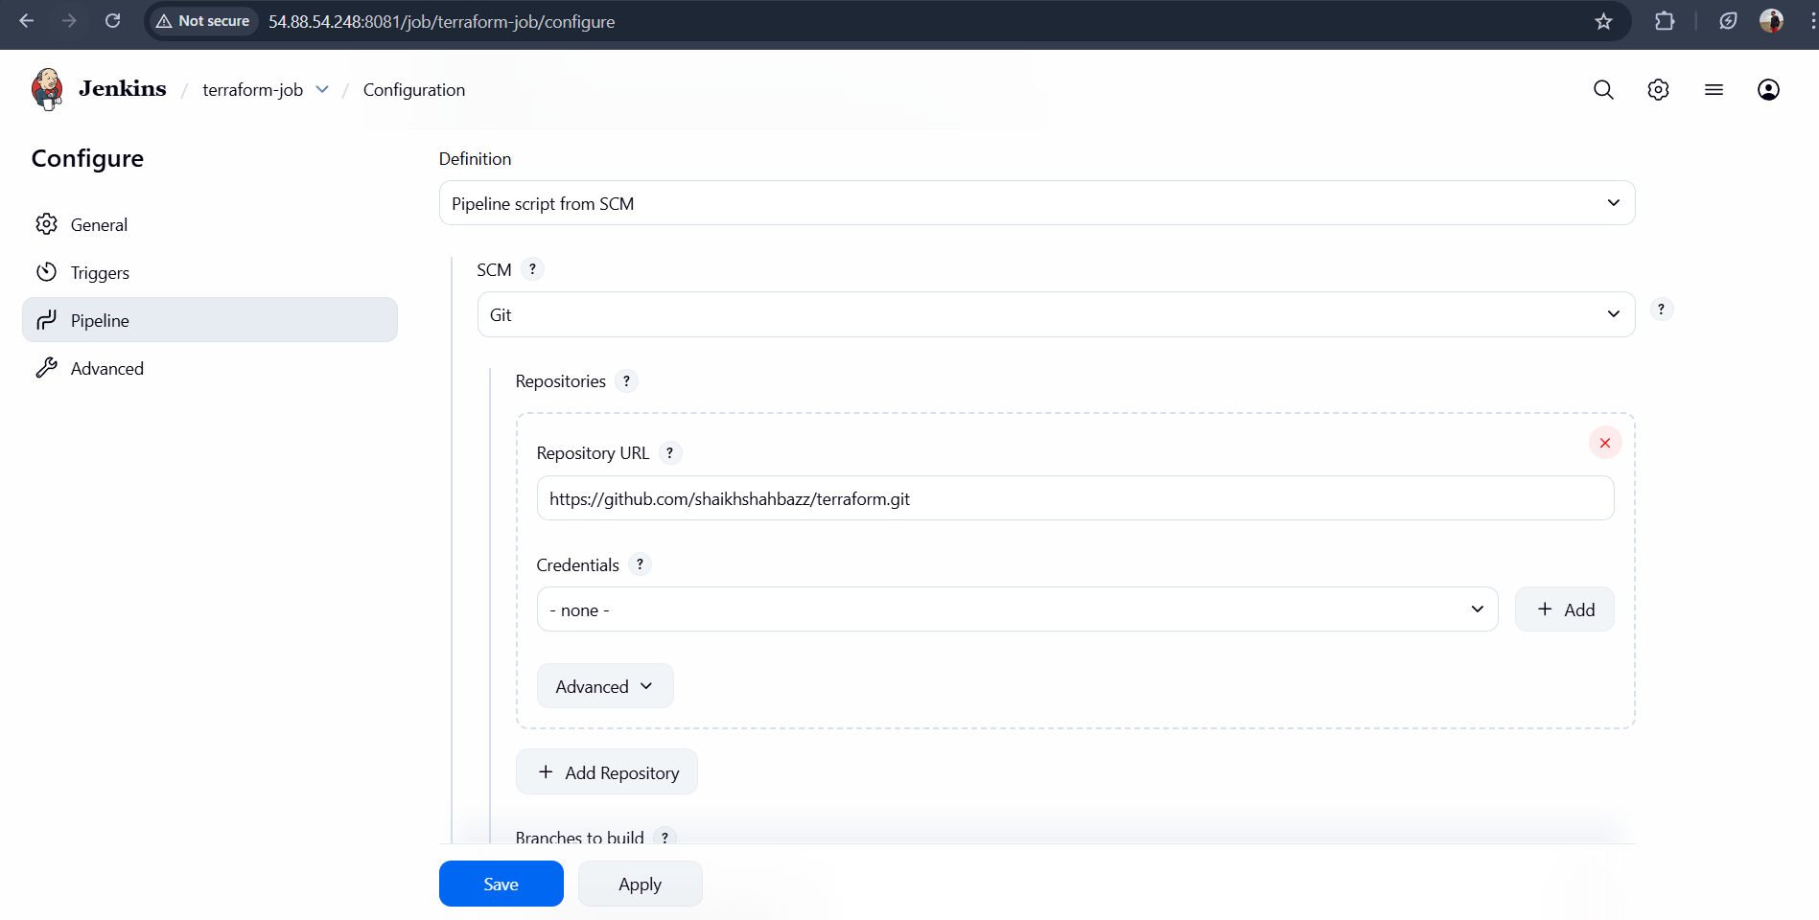
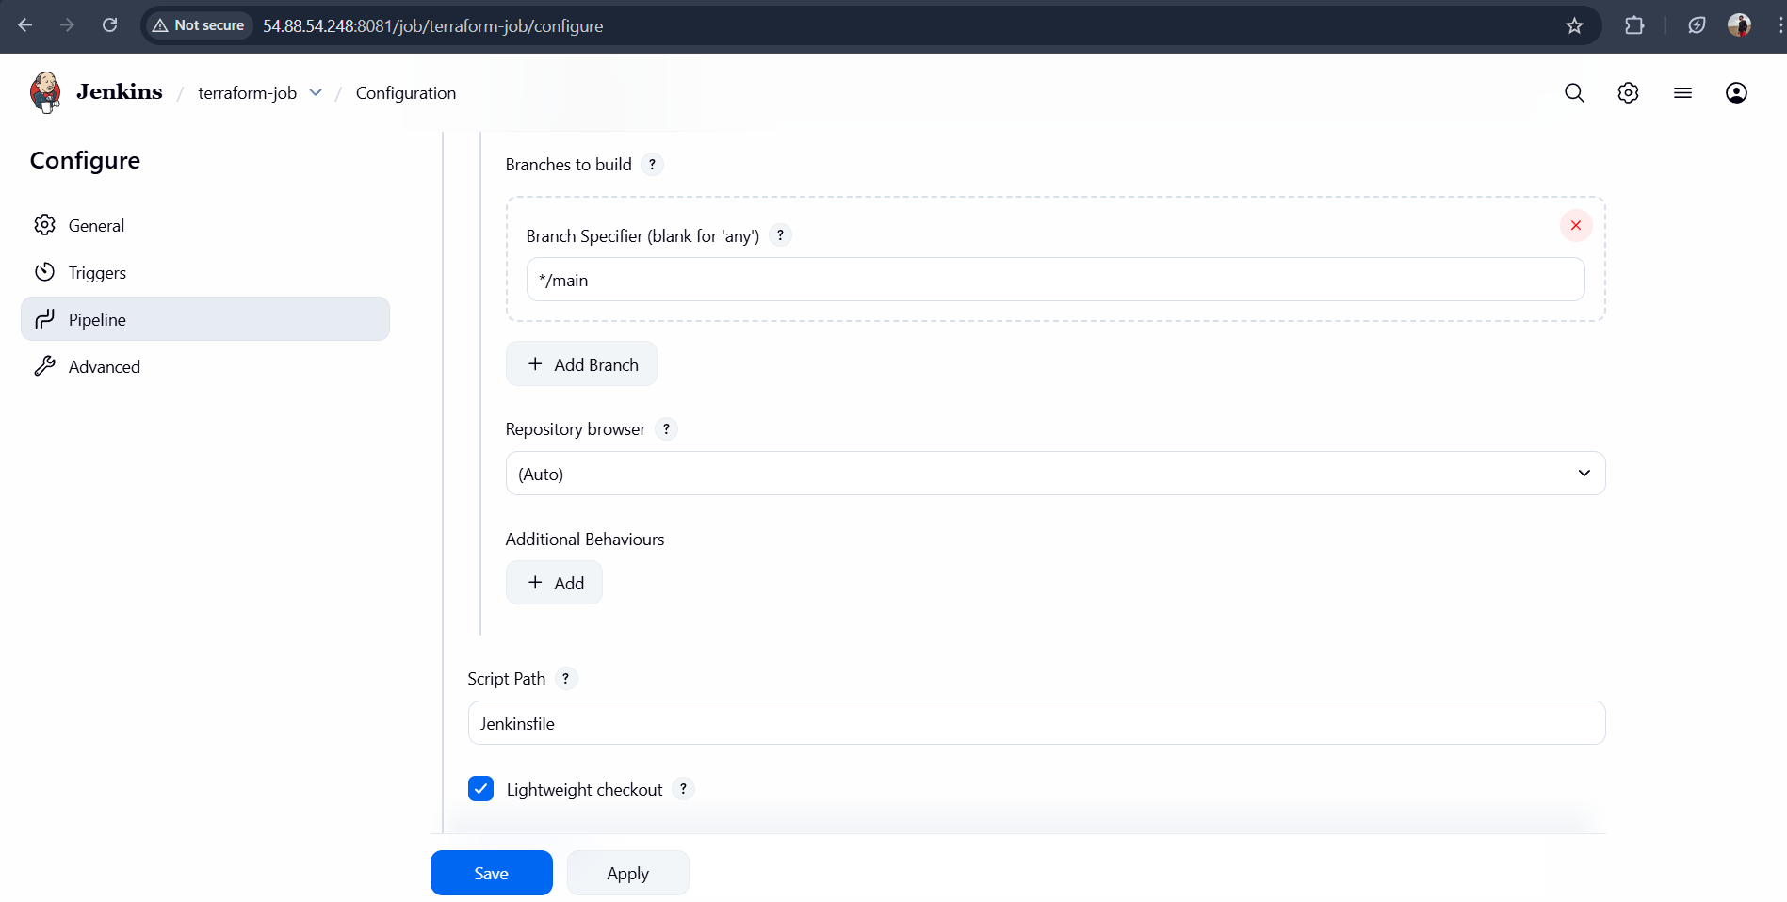

- Click Save and Buils now
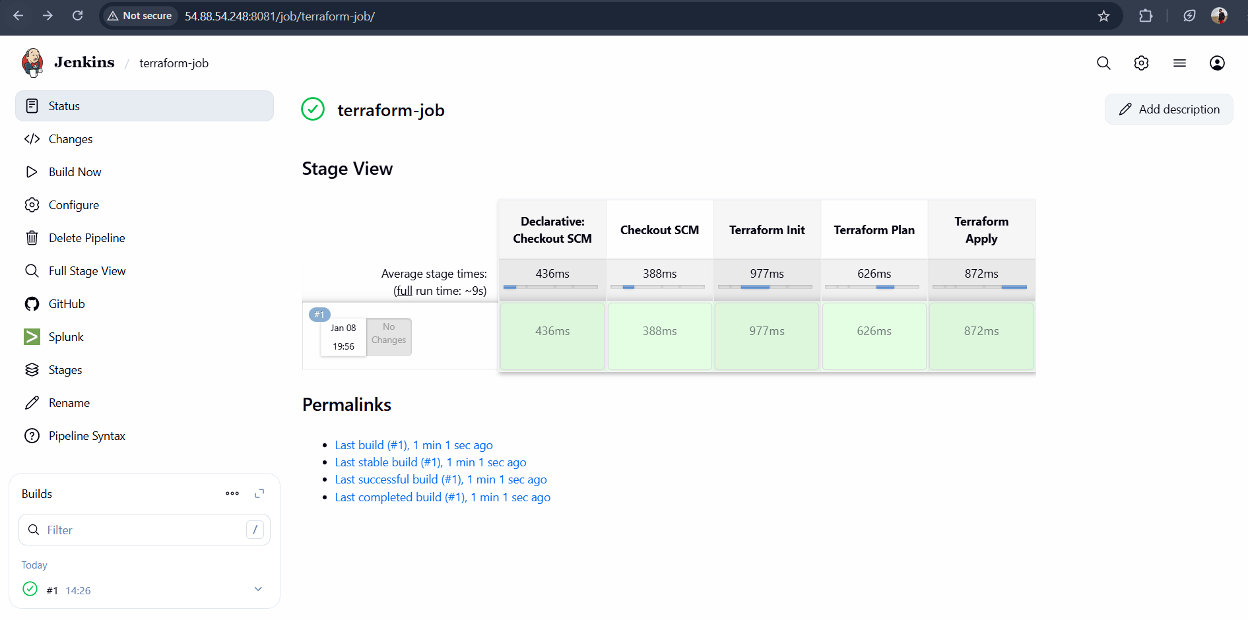
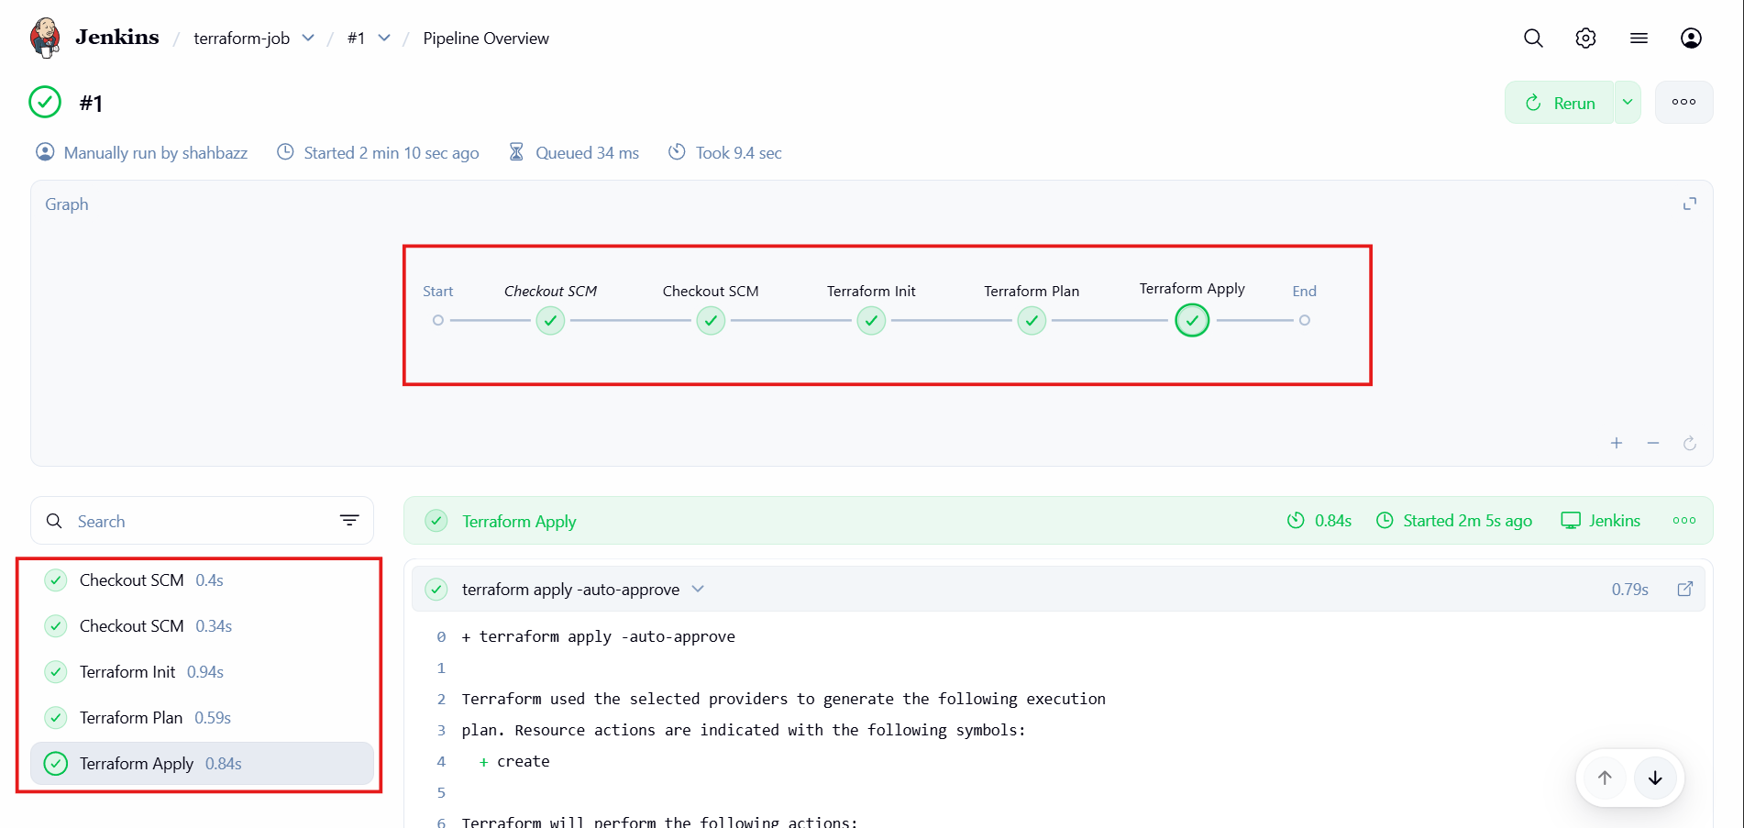
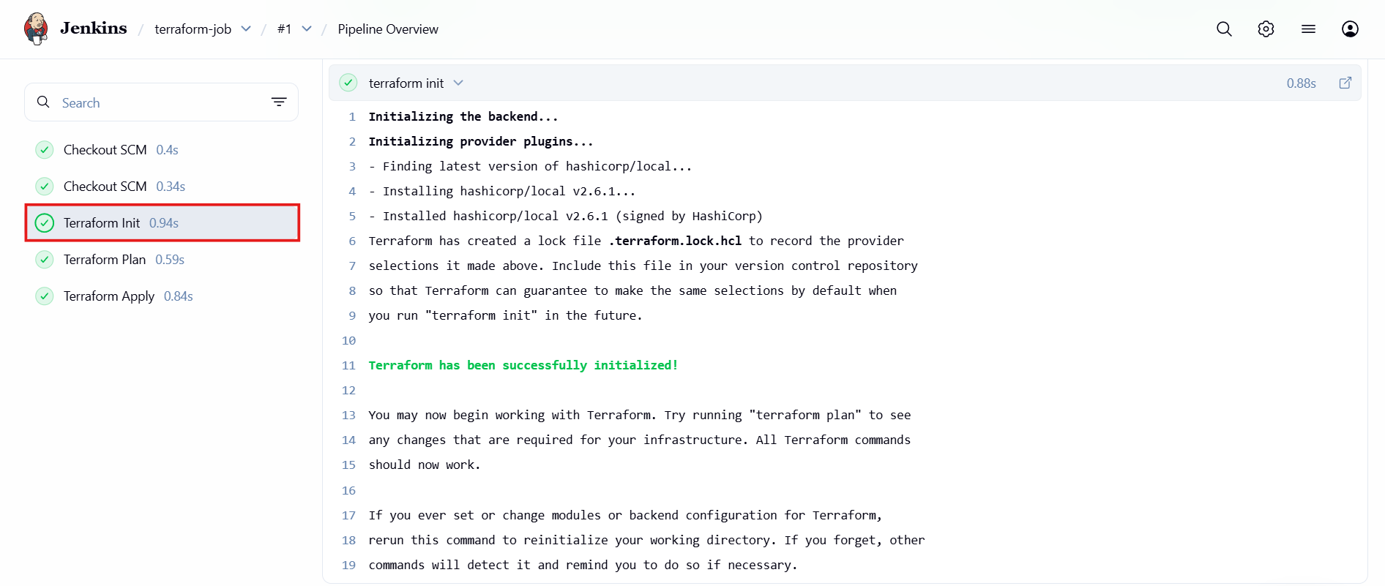
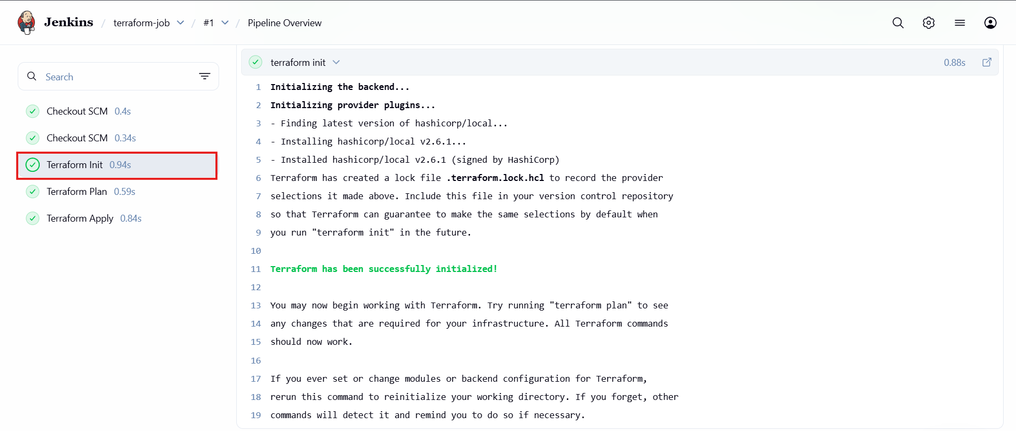
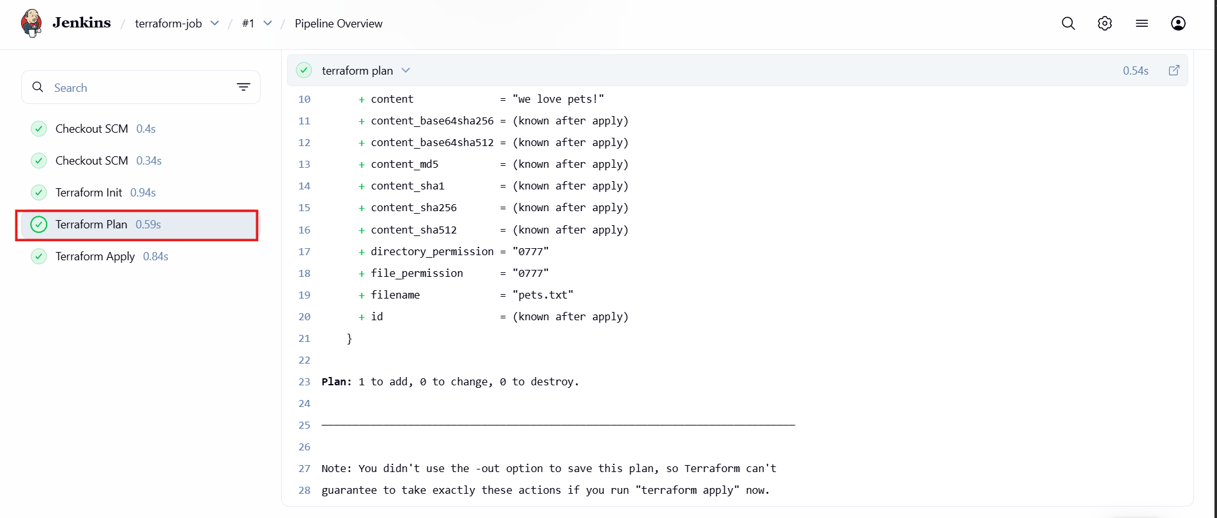
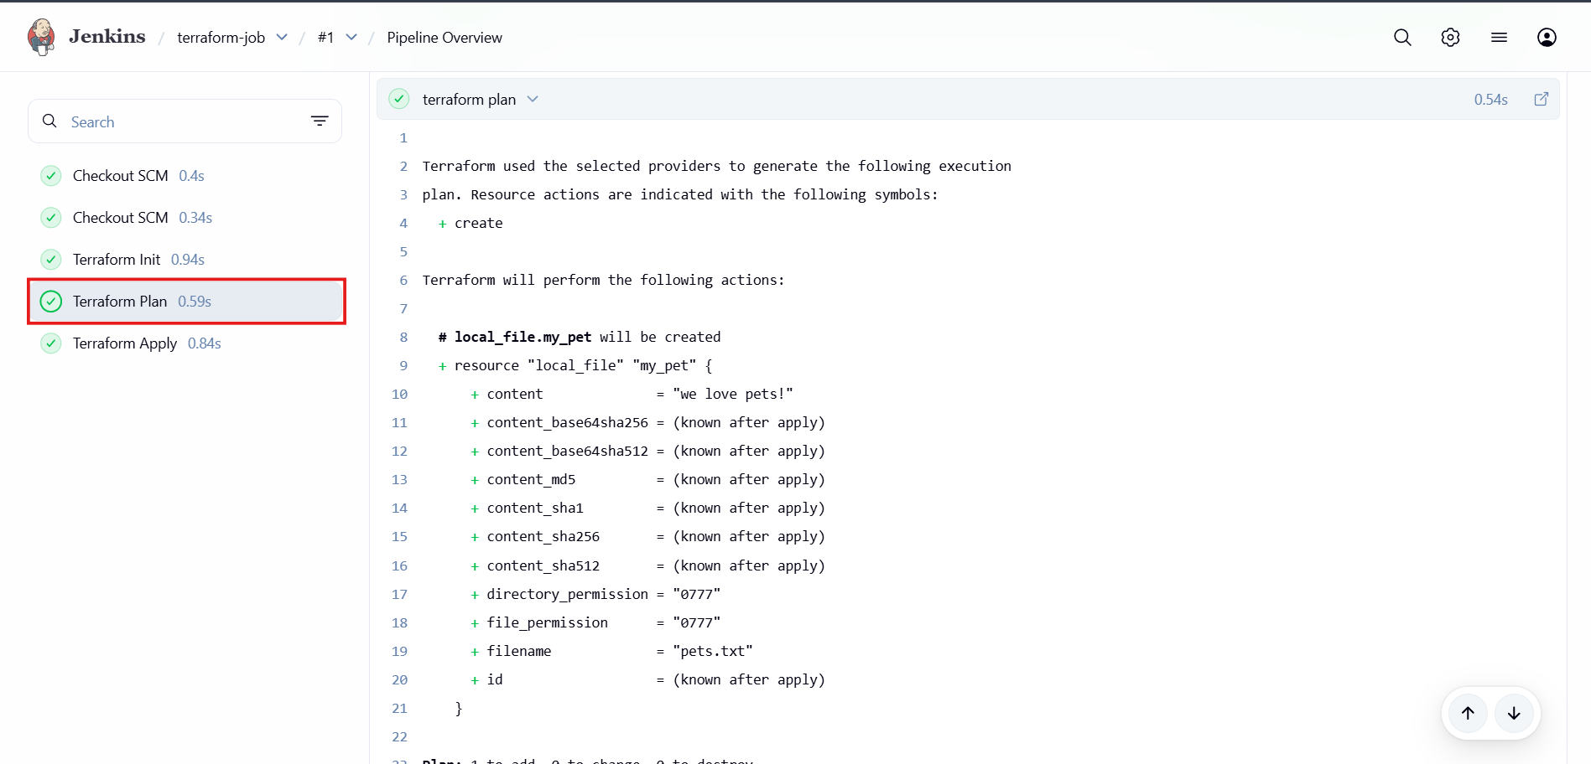
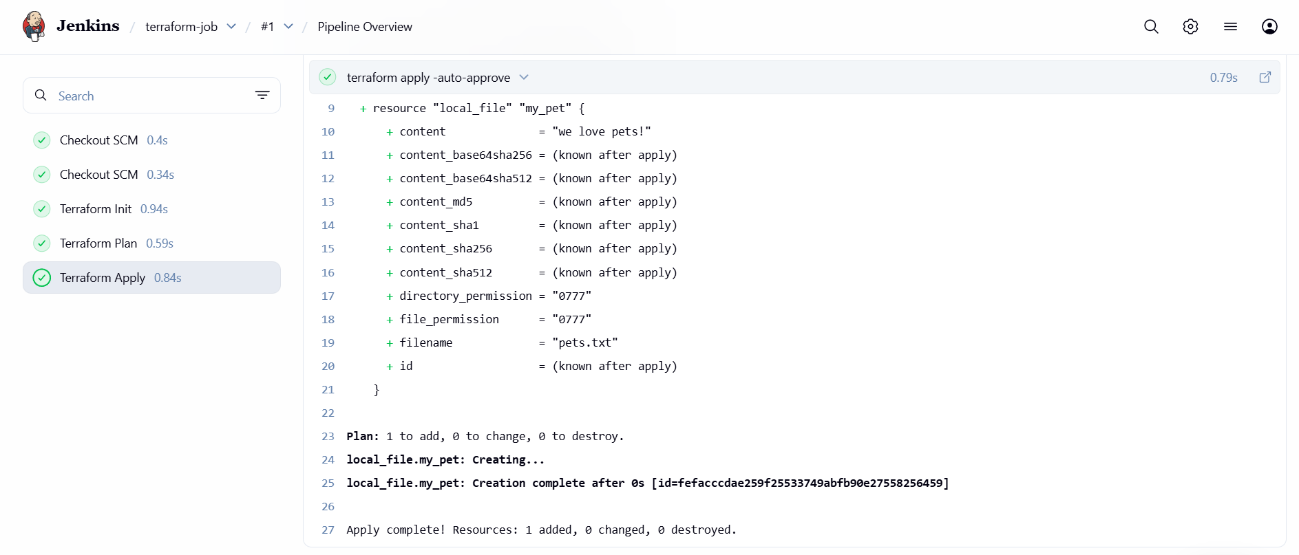

Verification :
Now lets check in Jenkins workspace
We are able to see the pets.txt file
—> now to confirm lets cat the file
